Procedure to start OpenFOAM: by Mohamed Alqadhi
15 November 2011
- Log on to VPN
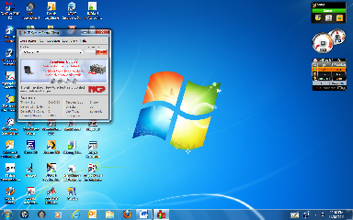
- Log on to SSH Secure Shell using one of the below addresses.
- 130.101.15.98 for cruncher I
- 130.101.15.97 for cruncher II
- Enter user name and password when prompted.
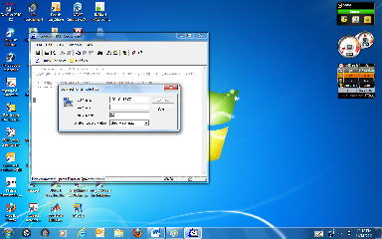
- Once logged on to shell, type in vncserver :10 on the command line.
- Go to tight VNC and logon to view screen with same password as shell.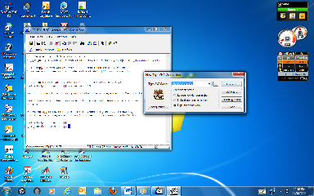
- A screen will pop up to show what it would look like when logged on in front of cruncher I or II.
- You will have two screens.
  - One the shell terminal.
  - And second the cruncher window screen view.
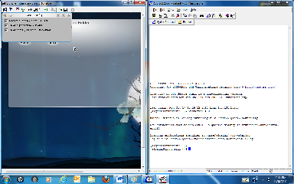
- Once on the cruncher go to and open up a second terminal called the terminal emulator from the start menu on cruncher.
- Go to shell and open up from the command line the file you want, e.g. cd OpenFOAM
- Once the final file destination is opened on shell, then you can go to the terminal emulator on cruncher and do the same as you did on shell.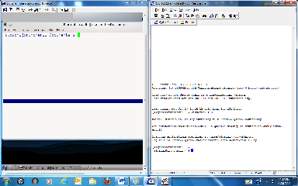
- For example opening cavity file for both terminals, shell first, then cruncher second.
- Next type paraFoam in the cavity directory on the terminal in cruncher and paraview will open.
- There post processing of the model will take place. Preprocessing can be described by the user guide on OpenFOAM.com website.

