Measurement of Filter Porosity using a Custom-Made Pycnometer
George Chase

INTRODUCTION
Porosity, permeability, and pore size distribution are three closely related concepts important to filter design and filter performance.

Porosity is a ratio of the volumes of the fluid space in a filter divided by the whole volume of the filter. Porosity is dimensionless and has values between zero and one. A typical value of porosity for a sand filter is about 0.3. A typical value of a nonwoven fiber medium is about 0.9.

Permeability quantifies how easy it is for a fluid to flow through a filter medium. Permeability is defined by Darcy’s law. It has units of area. A sand filter has a permeability in the range of 10⁻¹² to 10⁻⁹ m², depending on the size of the sand grains. A typical nonwoven microfiber filter medium has a permeability of about 10⁻¹⁰ to 10⁻⁹ m². A high permeability means the fluid flows faster through the medium compared to a lower permeability medium for the same filter size and applied pressure drop. Usually larger porosities correlate to higher permeabilities.

Pore size distribution is a measure of the size of the openings in a filter medium. Usually the pore openings of a typical filter vary in size. For a sand filter the pore openings can vary from a few microns to about a millimeter. For nonwoven microfiber media the pore openings can vary from a few tenths of a micron to a few hundred microns. Generally, media with larger pore openings have a higher permeability; but if the porosity is lower, then the permeability may be lower.

Various methods are reported in literature for measuring porosity, permeability, and pore sizes. This paper describes one method, using a custom-made pycnometer, to measure porosity. Pycnometers are commonly used to measure fluid or solid density. In reality, a pycnometer measures the volume of the substance, and by knowing the substance’s mass, the density is easily calculated.

The custom-made pycnometer determines the volume of the space in a filter medium that is occupied by the solid (fiber) phase from pressure measurements. The ideal gas law from physics is used to calculate the volume. By knowing the total volume of a filter sample the average porosity of the filter can be calculated.

THEORY
Consider a pycnometer constructed of two chambers connected by a short pipe and a valve as shown in Figure 1. Chamber 1 has volume V₁ and is initially vented to atmospheric pressure $P_{2}.$ Chamber 2 has volume V₂ and is filled with air at pressure $P_{2}$ using a pressurized air supply. The valve to the air supply is closed to isolate Chamber 2. We assume the two chambers and their contents are at the same temperature, T. This establishes the starting state for the system.

P
Chamber 2
Chamber 1
Vent
Air
Supply
V₂
P₂
V₁
P₁

Figure 1. Two empty chambers connected by a short pipe and valve.

The ideal gas law
$PV=nRT$ (1)
relates the volume, temperature, and pressure to the amount of gas (number of moles, n) in each chamber. R is the gas law constant with a value of 0.08205 (atm liter) / (g-mole K) or equivalently 10.73 (psi/(ft³ lb-mole R). Equation (1) is applied to each chamber to pressures and volumes to the moles of gas as
$P_{1}V_{1}=n_{1}RT$ (2)
$P_{2}V_{2}=n_{2}RT$ (3)

When the vent valve to Chamber 1 is closed and the valve between the two chambers is opened the gas flows between the chambers and quickly the pressure equilibrates. Let’s label this pressure P₃. The air at pressure P₃ is distributed over the volumes of both chambers $V_{1}+V_{2}$ and the total moles of air is conserved, hence
$P_{3}\left(V_{1}+V_{2}\right)=\left(n_{1}+n_{2}\right)RT$ (4)

Equations (1), (2), and (3) may be combined and rearranged to
$V_{2}=\frac{P_{1}-P_{3}}{P_{3}-P_{2}}V_{1}$ (5)
which shows $V_{2}$ can be determined from the pressures and $V_{1}$.

Next, consider the operation when a filter sample is placed in Chamber 1. As shown in Figure 2, the volume of Chamber 1 that is occupied by the air is $V_{1}-V_{F}$ where $V_{F}$ is the volume of the fibers and is the quantity needed to calculate porosity.

P
Chamber 2
Chamber 1
Vent
Air
Supply
V₂
P₅
V₁-V_{F}
P₄
FILTER

Figure 2. Two chambers connected by a short pipe and valve. Chamber 1 holds a filter sample of unknown volume, $V_{F}$.

The pressures in Chambers 1 and 2 are labeled $P_{4}$ and $P_{5}$. When the valve is opened between the chambers the equilibrium pressure is $P_{6}$. The ideal gas law written for this situation are
$P_{4}\left(V_{1}-V_{F}\right)=n_{4}RT$ (6)
$P_{5}V_{2}=n_{5}RT$ (7)
$P_{6}\left(V_{1}-V_{F}+V_{2}\right)=\left(n_{4}+n_{5}\right)RT$ (8)

Equations (6), (7) and (8) can be combined to obtain a relation for $V_{F}$
$V_{F}=V_{1}+\frac{P_{5}-P_{6}}{P_{4}-P_{6}}V_{2}$ (9)

Equations (9) and (5) are two independent equations and three unknowns ($V_{1}$, $V_{2}$, and $V_{F}$). To use these equations to find $V_{F}$ we need one more equation to independently determine $V_{1}$ or $V_{2}$.

We can obtain an third equation if we insert an object of known volume into Chamber 1 in place of the filter, as shown in Figure 3. The dimensions of the cube are measured using a micrometer and the volume calculated. Here, the pressures in Chambers 1 and 2 are labeled $P_{7}$ and $P_{8}$. When the valve is opened between the chambers the equilibrium pressure is $P_{9}$.

P
Chamber 2
Chamber 1
Vent
Air
Supply
V₂
P₈
V₁-V_{C}
P₇

Figure 3. Two chambers connected by a short pipe and valve. Chamber 1 holds a calibration cube of known volume, $V_{C}$.

The ideal gas laws written for this situation yield the expression
$V_{C}=V_{1}+\frac{P_{8}-P_{9}}{P_{7}-P_{9}}V_{2}$ (10)

Now we have three equations (5), (9), (10) and three unknowns. The ideal gas law requires the pressures to be absolute pressures. Fortunately, pressure differences are the same whether written in gauge or absolute pressure units. Because Chamber 1 is initially vented to atmospheric pressure, then the gauge pressures $P_{1}, { P}_{4}, P_{7}$ are zero.

Equations (5) and (9) simplify to
$V_{2}=\frac{P_{3}}{P_{2}-P_{3}}V_{1}$ (11)
$V_{F}=V_{1}-\frac{P_{5}-P_{6}}{P_{6}}V_{2}$ (12)

Equation (10) is combined with Eq.(11) to obtain an expression for calculating $V_{1}$,
$V_{1}=\frac{V_{C}}{1- \frac{P_{8}-P_{9}}{P_{9}} \frac{P_{3}}{P_{2}-P_{3}}}$ (13)

Now we have all the tools we need to determine the volume of the fibers in the filter and to calculate the porsosity. The Pycnometer is operated three times to obtain six pressure measurements. This is summarized in Table 1. Equations (11), (12), and (13) are used to calculate the three volumes.
The macroscopic volume of the filter, $V_{FILTER}$, is determined by measuring its external dimensions. The porosity is calculated by the expression
$ε=1- \frac{V_{F}}{V_{FILTER}}$ (14)

Table 1. Summary of measurements and calculations to determine the porosity of a filter.
MEASURED DATA
Macroscopic Volume of Filter Sample | $$V_{F}$$
Volume of Calibration Cube | $$V_{C}$$
PYCNOMETER MEASURMENTS
 | Pressure Measurements
 | Interchamber Valve  Closed | Interchamber Valve  Open
Chamber 1 Empty | $$P_{2}$$ | $$P_{3}$$
Chamber 1 with Filter Sample | $$P_{5}$$ | $$P_{6}$$
Chamber 1 with Calibration Cube | $$P_{8}$$ | $$P_{9}$$
CALCULATIONS
 | Quantity | Equation
Volumes | $$V_{1}$$  $$V_{2}$$  $$V_{F}$$ | (13)  (11)  (13)
Porosity | $$ε$$ | (14)

PRACTICAL CONSIDERATIONS
Some practical considerations for applying the pycnometer are listed here.

- The pycnometer may easily be machined out of aluminum as shown in Figures 4 and 5.
- The pycnometer works best for measuring porosity of filter media of substantial thickness (a few millimeters to a few centimeters).
- Porosity of thin media may be measured by stacking layers of the media in to Chamber 1. However, when calculating the macroscopic volume of the stacked layers it is best to measure the volume of one layer and multiply by the number of layers. This latter avoids error caused by gaps between the layers.
- The volume size of Chamber 1 should be slightly larger than the macroscopic dimensions of the filter sample. Nonwoven filter media typically have high porosities and hence small volumes of fibers. The small volumes of fibers means the volume difference $\left(V_{1}-V_{F}\right)$ in Eq.(6) is approximately equal to $V_{1}$ and higher accuracy pressure measurements are needed to reduce measurement error.
- The pycnometer approach to measure porosity is sensitive to any location that the pressurized gas can penetrate. The air will penetrate into internal pores and dead-end pores. Internal pores usually do not contribute significantly to fluid flow through a filter. Dead-end pores do not allow fluid to flow. In these latter situations, the measured porosity may not correlate well with permeability and capture efficiency.
- It is best if the filter sample has a regular shape such as a square or disk so that the macroscopic volume can easily be calculated.
- Filter media often have irregular thicknesses. The thickness should be measured at multiple locations and averaged.

Figure 4. Components of custom-made pycnometer.

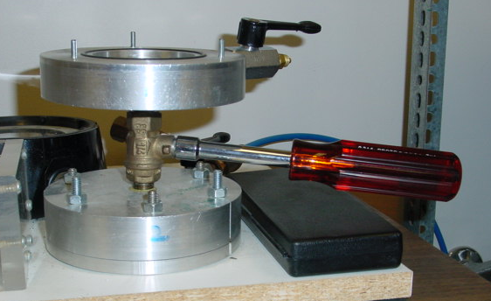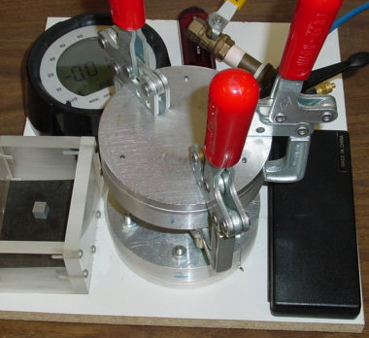
Side View Assembled View

Figure 5. Side view and assembled view of custom-made pycnometer.

